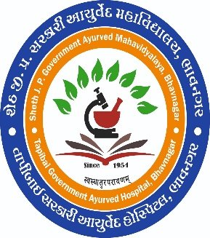 | Sheth J.P. Government Ayurved College & Hospital  Opp. Sardarbaug, Panwadi, Bhavnagar  (Affiliated with Gujarat Ayurved University, Jamnagar)  Under the  Office of Director-AYUSH, H&FW Department, Govt. of Gujarat  Website: : www.ayurjpbhavnagar.ultimatefreehost.in E-mail: jpgovt@gmail.com Phone No. : (0278)2424142

SUMMARY REPORT

Name of institute | SHETH J P GOVT. AYURVED COLLEGE BHAVNAGAR
Policy | SSIP2.0 EDUCATION DEPT. GOVT.OF GUJARAT
Name of programs | STUDENT START UP &INNOVATION AWARNESS WORKSHOP
Date of programme | 12/10/2023
Type of program | Start up sensitization and awareness
Total no. of beneficiaries | 139 STUDENTS + FACULTIES
Venue | Dhanvantari Hall , SJPAC, Bhavnagar
Speaker | Shri Rhizawan Ghanchi,  Shri Narwarsingh gohil
No. of days | 1
Time | 10 AM -1 PM 3Hrs
Expense | Rs 2315 /-
Coordinator | Dr Nitesh Gupta
Principal | Dr. Naresh Kumar Jain

